1. 
2. 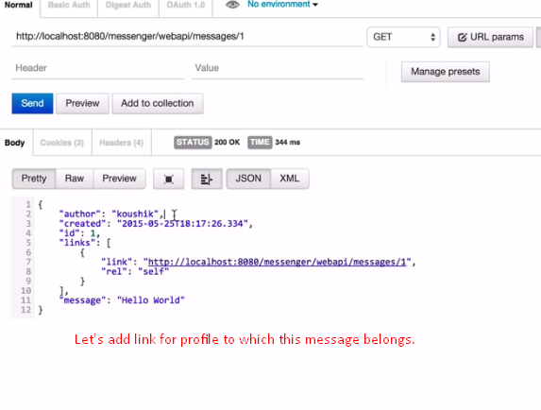 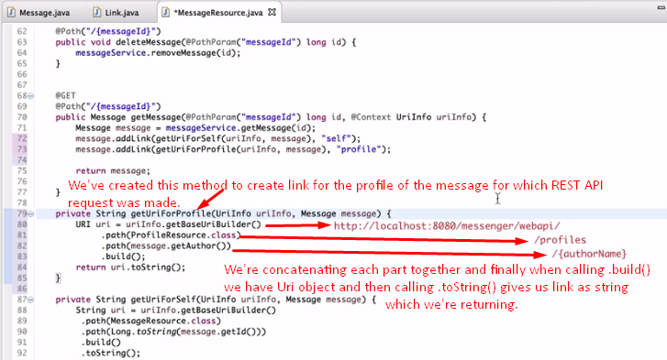 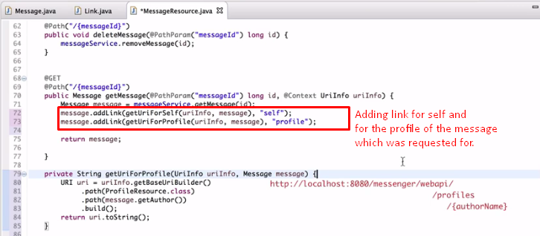 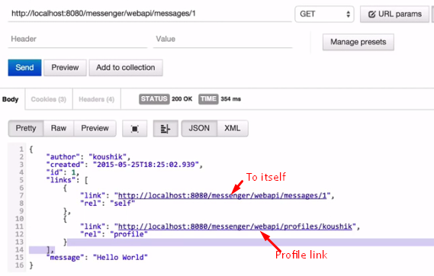
3. Let’s add links for all the comments for the requested message.
4. 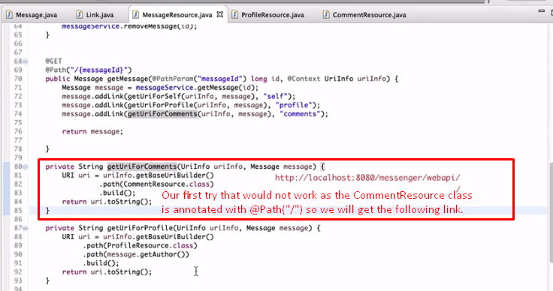 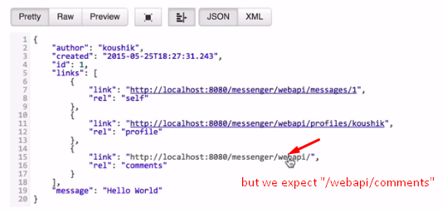
5. One thing more. As comment resource is sub-resource of message resource. So, accordingly, we have defined a method in Message.java (@Path(“messages/”) resource class   
   which is annotated with @Path(“{messageId}/comments”) and the Comment Resource class is annotated with @Path(“/”) and   
   Let’s see in pictorial way:  
   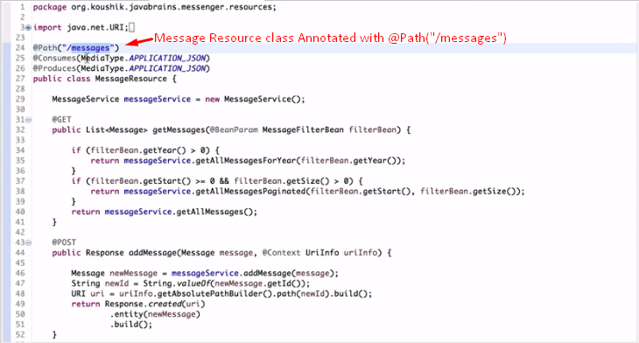 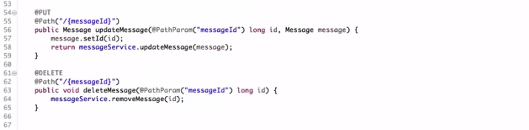 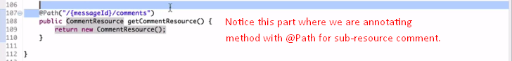 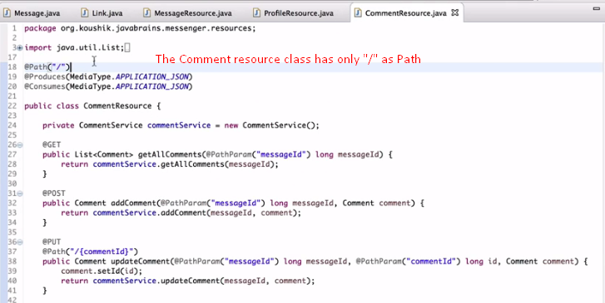
6. So, Going from Message resource class, through the sub-resource method in this class up to Comment class, we have to build the path.
7. 